Ch.5 Lab1 Exercises

# Task 1

# Write a program and define a function named **find_sum** to calculate the sum of numbers from 0 to n, where n is a number entered by the user*.*

# *The input and print functions should be in the main function.*

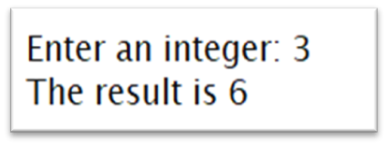

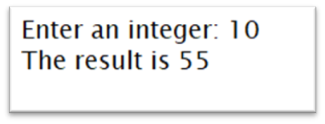

|  |
| --- |

|  |
| --- |

|  |
| --- |

# 

# Task 2

Write a program and define a function called **evaluates** that combines two integer numbers with an operator that is given as a string "+", "-", "*", "/", or "**" (raising to a power) and print the result of evaluating the operator with the arguments.

For example,

evaluate("**", 10, 2) should print 100 as a result.

# 





  
  

  
  

  
  